**DENTED CANS**

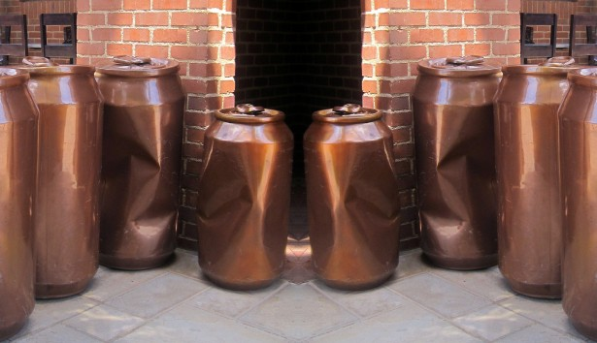

**Return to the Vendor**